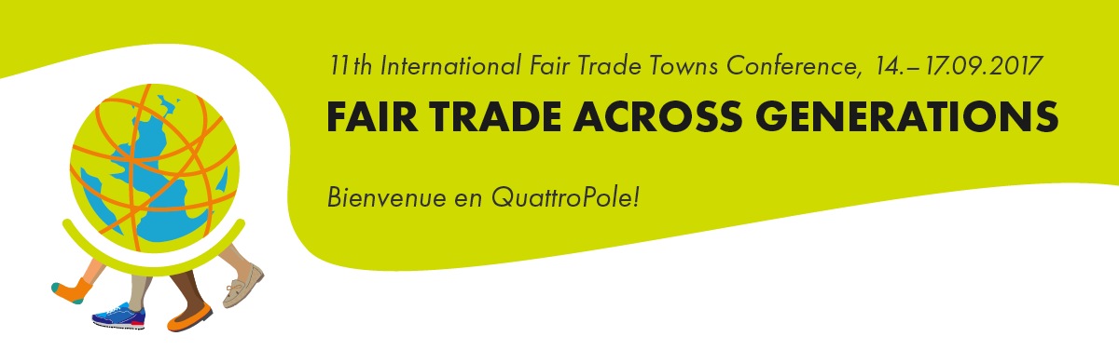

www.quattrofair.org

Press release on the 5th of September 2017

The Future of Fair Trade in the EU

Thematic focus of the International Fair Trade Towns Conference (IFTTC) on the 15.09.2017 in Saarbrücken
On the 15th of September from 10:30 to 12:15, representatives of various European institutions will come together at the International Fair Trade Towns Conference (IFTTC) to discuss the future of Fair Trade on a European level.
Sandra Gallina, director for sustainable development and trade at the European Commission, will present the role of the EU in the promotion of Fair Trade in her key note speech and will announce the new award “EU Capital for Fair and Ethical Trade”, due to commence in 2018. Together with the successful German competition “Capital of Fair Trade” (Saarbrücken is the award winner for 2015-2017) and the international campaign “Fair Trade Towns”, the competition aims to strengthen the engagement for Fair Trade in Europe.
Following a second speech by Jean Feyder, the ambassador of the United Nations in Luxemburg, a panel debate will be held with five EU delegates of different political colour from the three neighbouring countries of France, Luxemburg and Germany. The delegates will debate the possibilities and the limitations of a fair-trade policy, both amongst themselves and together with the audience.
Throughout the morning, the role of the moderator will be filled by Sergí Corbalán, managing director of the Fair Trade Advocacy Office (FTAO). In the form of a European network based in Brussels, the FTAO carries out political persuasive efforts with the EU bodies.
The EU will also be a central topic in the afternoon’s workshops. For example, the question “what are the consequences of the new EU sugar policy for sugar producers in the global South?” will be addressed together with Ruth Salditos from the Philippines. Ruth Salditos is the managing director of the Panay Fair Trade Center which, among other things, is responsible for exporting fair trade sugar.
*****
The IFTTC is an annual meeting point for international, national and local stakeholders of Fair Trade and Fair Trade Towns. International collaboration as well as strategies for success in national campaigns will be further areas of focus throughout the conference. Alongside talks and presentations, there will be several workshops that address both specific measures such as the engagement within a university campus and the sustainable procurement within city administration, as well as worldwide issues including the Sustainable Development Goals of the UN and the global development of the Fair Trade system.
The conference is organised by the Fairtrade Initative Saarbrücken (FIS) and its QuattroFair partner organisations in Luxemburg, Metz and Trier. The event will take place in cooperation with the International Fair Trade Towns Steering Committee, Fairtrade International (FI) and the World Fair Trade Organization (WFTO)
For online accreditation for journalists and members of the press please visit following link: http://www.quattrofair.org/news-and-presse.html
Contact: ORGA-Team PR at the Fairtrade Initiative Saarbrücken
Diana Rode, d.rode@faires-saarland.de
Heike Zimmermann, heikemariazimmermann@t-online.de , Mobile: +49 151 15695341
Links:
Fairtrade International: http://www.fairtrade.net
World Fair Trade Organization: http://www.wfto.com
International Fair Trade Towns Steering Committee: http://www.fairtradetowns.org/contacts/int-ftts-steering-committee
Fair Trade Towns – National Coordinators: http://www.fairtradetowns.org/contacts/national-coordinators
Fairtrade Germany http://www.fairtrade-deutschland.de
QuattroPole http://www.quattropole.org
QuattroFair http://www.quattrofair.org
Fairtrade Initiative Saarbrücken (FIS) http://www.faires-saarbruecken.de

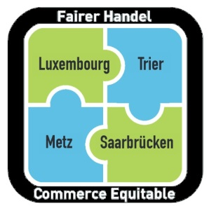
Nos quatre villes s’engagent ensemble pour le Commerce équitable!
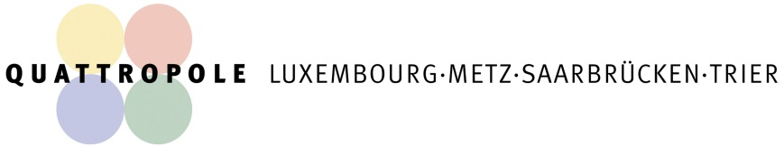
Unsere vier Städte engagieren sich gemeinsam für den Fairen Handel!

